# YOGA APPLICATION

### A MINI PROJECTREPORT

#### Submittedby

#### Group: G7

**KHUSHI JAIN(2310991434)**

#### in partial fulfillment for the award of the degree of

## BACHELEOR OF ENGINEERING

***in***

COMPUTER SCIENCE & ENGINEERING



**CHITKARA UNIVERSITY**

**CHANDIGARH-PATIALA NATIONAL HIGHWAY**

**RAJPURA (PATIALA) PUNJAB-140401 (INDIA)**

##### JUN-DEC&2023-27

###### TABLE OF CONTENTS

|  |  |  |
| --- | --- | --- |
| Sr.no | Section | Pageno. |
| 1. | INTRODUCTION | 3 |
| 2. | PROBLEM STATEMENTS | 4 |
| 3. | TECHNICAL DETAILS | 5 |
| 4. | KEY FEATURES | 6 |
| 5. | PROJECT ADVANTAGES | 7 |
| 6. | RESULT | 8 |
| 7. | CONCLUSION | 9 |

# INTRODUCTION

In the fast-paced digital age, where wellness takes center stage, the Online Yoga Project emerges as a transformative platform, seamlessly integrating the ancient practice of yoga with the accessibility and convenience of the internet. This project is a virtual sanctuary for individuals seeking a holistic approach to physical and mental well-being, providing a gateway to the age-old wisdom of yoga through the click of a button. The Yoga lax project is a comprehensive web platform designed to promote and facilitate the practice of yoga. This project aims to provide users with a seamless experience in exploring and engaging with yoga classes, membership options, success stories, blog posts, and a gallery of related images.

The convergence of HTML, JavaScript, and CSS enables the creation of a visually engaging and user-friendly platform. HTML forms the backbone of the project, providing the structural framework for content organization. CSS complements this structure by enhancing the aesthetic appeal and ensuring a visually captivating interface. JavaScript acts as the driving force behind the project's interactivity, enabling dynamic elements and facilitating user engagement.

**HTML Structure:** Detailing the hierarchical arrangement of elements to create a cohesive and user-friendly interface.

**CSS Styling**: Discussing the design choices, visual enhancements, and responsive layouts implemented to elevate the user experience.

**JavaScript Functionality:** Describing the interactive features, event handling, functions usage, alerts , methods…etc.

# PROBLEM STATEMENT

**Limited Accessibility**: Recognize the constraints of traditional yoga practices being confined to physical spaces, limiting accessibility for individuals in various geographical locations.

**Time Constraints**: Acknowledge the time constraints faced by individuals due to busy schedules, making it challenging to attend regular in-person yoga classes.

**Stress and Mental Health**: Highlight the prevalence of stress, anxiety, and mental health issues in today's fast-paced world, emphasizing the need for practices that promote mental well-being.

**Physical Inactivity**: Discuss the consequences of a sedentary lifestyle and the importance of physical activity for maintaining good health and preventing lifestyle-related diseases.

**Need for Personalization**: Recognize the diverse needs of individuals, including varying levels of expertise, preferences, and fitness goals, and emphasize the need for personalized yoga experiences.

**Geographical Barriers**: Point out how geographical barriers can hinder individuals from accessing quality yoga instruction, especially in areas with limited availability of yoga studios or instructors.

**TECHNICAL DETAILS**

The technological foundation of Yoga lax is built on a modern web stack.

**HTML Structure**: Utilized semantic HTML5 elements such as <header>, <footer>, <form>, <marquee>, <main>, <section>, etc., for better structure and accessibility.

**CSS Styling**: Utilized CSS elements such as<box-shadow>, <hover>, <visited>, <cursor pointer>, <blinker>, <background-repeat>, <border radius> Etc. to make our webpage look better.

**Layout Design**: Implement a responsive layout using CSS Grid, or other layout techniques for a visually appealing interface.

**JavaScript Functionality**: Implemented few features of java script like var, function , alerts, methods, get function, etc. to make our project workable and user friendly.

**KEY FEATURES**

**Responsive Navigation**: The website has a responsive navigation menu, allowing users to easily navigate between different sections.

**Engaging Header:** The header section includes a visually appealing image, a headline promoting effective yoga, and a call-to-action button for a 15-day free trial.

**Why Yoga Section:** A section emphasizing the benefits of yoga, accompanied by relevant icons and a list highlighting key advantages.

**Hero Section**: Highlights key aspects of a healthy lifestyle, body and mind balance, meditation practice, and self-care through visually appealing cards.

**Yoga Classes Section**: Displays images of different yoga classes with a "View More" button, encouraging users to explore various class options.

**Membership Pricing Table**: Clearly presents membership plans with pricing, duration, and features, providing users with options for different subscription periods.

**Successful Stories/Testimonials Section**: Features testimonials from users, adding credibility to the platform.

**Banner Section**: Highlights key statistics such as happy customers, yoga workshops, years of experience, and lessons conducted, reinforcing the platform's reliability.

**Blog Section:** Showcases recent blog posts with images, dates, and short descriptions, encouraging users to explore relevant content.

**PROJECT ADVANTAGES**

**User-Friendly Design:** The website follows a clean and organized layout, ensuring a positive user experience.

**Engaging Visuals:** Effective use of images and icons throughout the site enhances engagement and communicates information visually.

**Clear Call-to-Action:** The call-to-action button in the header encourages users to sign up for a free trial, increasing conversion opportunities.

**Informative Content:** Sections such as "Why You Should Go To Yoga" and "Membership Cards" provide informative content that helps users understand the platform's value.

**Social Media Integration:** The footer includes links to social media profiles, allowing users to stay connected and informed.

**Copyright Information:** The footer includes copyright information, demonstrating professionalism and legal compliance.

**Consistent Branding:** The consistent use of the Yoga lax logo and brand colors contributes to a cohesive branding strategy.

**Global Accessibility:** Yoga lax breaks down geographical barriers, allowing users from around the world to engage in yoga anytime, anywhere.

**Personalized Experience:** Tailored classes cater to individuals of all levels, providing a personalized journey toward physical fitness and mental well-being.

**RESULT**

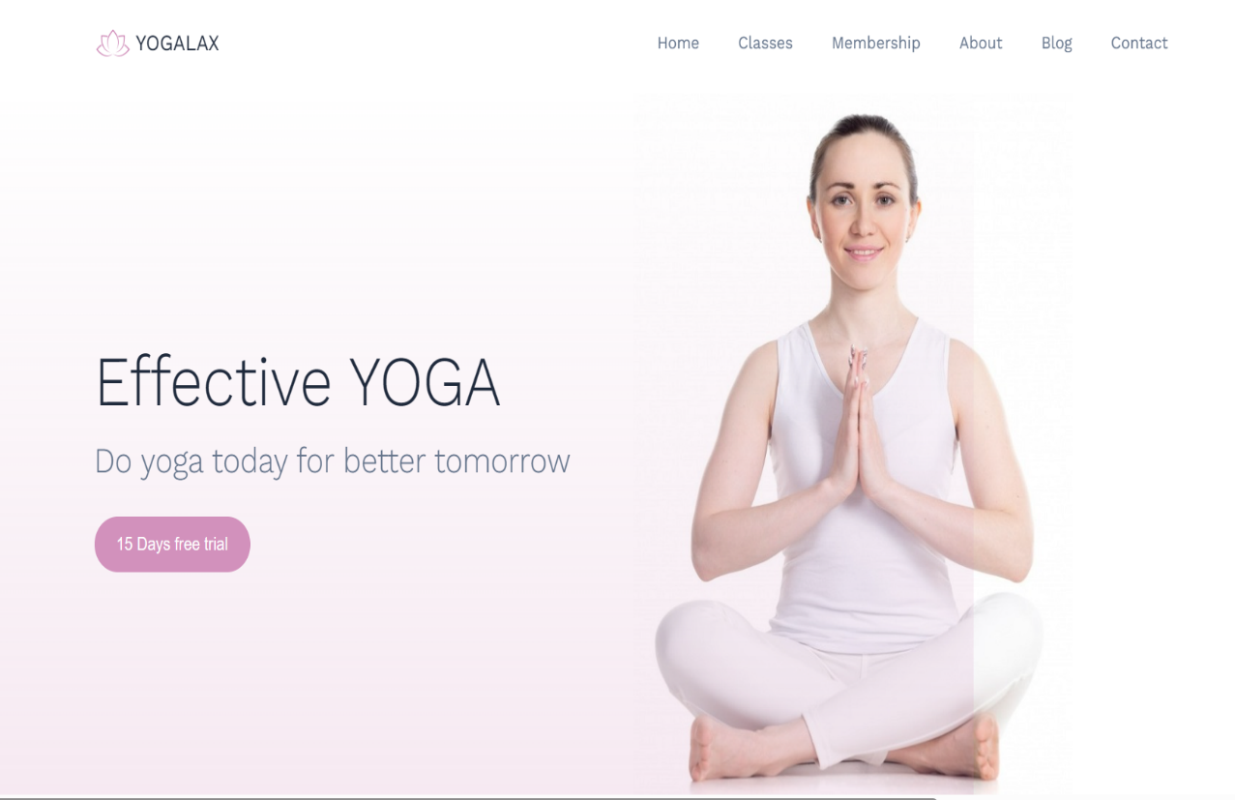



**CONCLUSION**

The journey of Yoga lax doesn't end here. Future developments may include the integration of virtual reality (VR) for immersive yoga experiences, expansion of the class repertoire, and partnerships with wellness experts to provide a comprehensive well-being ecosystem.

Yoga lax invites individuals to embrace the transformative potential of yoga in the digital age, encouraging a global community dedicated to the pursuit of wellness. Let the journey to a healthier tomorrow begin with Yoga lax.

By using the power of the internet, this platform invites individuals to embark on a transformative journey towards a healthier and more balanced life.

# THANKYOU

